AUTOMATIC FLOOR CLEANING ROBOT
Sneha Talsandekar,Reshma Kolap, Aishwarya Bhakare, Nikita More
Mrs. Asst. Prof. Seema G. Bavachkar

Student., Department of Computer Engineering, ATS’s Sanjay Bhokare Group of
Institute, Sangli, Maharashtra, India
* 4Prof, Department of Computer Engineering, ATS’s Sanjay Bhokare Group of Institute,
Sangli, Maharashtra, India

ABSTRACT

Wireless technologies are becoming more prevalent around the world and the people or users appreciate this wireless technology which gives them knowledge about different tasks which can be performed through wireless, reduce human power and time consume and it’s secured one. Technology is a never-ending process and to design product using the current technology that will be beneficial to the lives of others is a massive contribution to the community.
Bluetooth technology is one of the wireless technologies used to transfer information between different electronic devices and less impediment, power consumption, accessible at cheaper rates etc.
Keywords: Accessible, Affordable, Convenience, Efficiency, Security

- INTRODUCTION

Wireless technologies are becoming more prevalent around the world and the people or users appreciate this wireless technology which gives them knowledge about different tasks which can be performed through wireless, reduce human power and time consume and it’s secured one. Technology is a never-ending process and to design product using the current technology that will be beneficial to the lives of others is a massive contribution to the community.

Bluetooth technology is one of the wireless technologies used to transfer information between different electronic devices and less impediment, power consumption, accessible at cheaper rates etc. In this work, “Mobile aided Arduino nano based floor cleaning robot using ultrasonic sensor” is designed for floor buildings.

Here floor cleaning robot is proposed that is controlled through android application and ultrasonic sensor for floor cleaning purpose it can also work automatically. Floor cleaning robot is designed to make housework process become easier for human task and reduce dirty. The mopper makes floor cleaning very easy and fast processing using rotating dc motor.

- OBJECTIVES:

The objectives of this project are given below:

- To simplify human life
- To avoid time wastage during cleaning.
- To develop an android application that sends a set of instructions from mobile phone for controlling purpose.
- To interface Bluetooth module with Arduino.
- To identify the specifications of each component used while designing.

- PROPOSED DESIGN:

  - METHOLOGY USED:

The methodology part is used to define about how the project should be developed and finalized. Therefore, the steps to conduct the development of this project are divided into three phases that has shown in the figure given below.
In first phase, the project workflow involve literature review which related in floor cleaning robot system that conducted by previous researchers and projects. The next phase introduces the propose design that involve hardware and software implementation in this project. Finally, integrate the system, testing system and finalize the documentation.

  - COMPONENT USED IN THE PROJECT:
• Processing unit (Arduino nano)
• Actuating units
• Survo motor
▪ DC gear Motors
▪ Water tank
• L293D Motor Driver
• Wheels
• HCSR04 Ultrasonic Sensor
• Battery
• Some components like point pcb, nut bolts, screws. Wires (jumpers) etc.

4.FIGURES AND TABLES

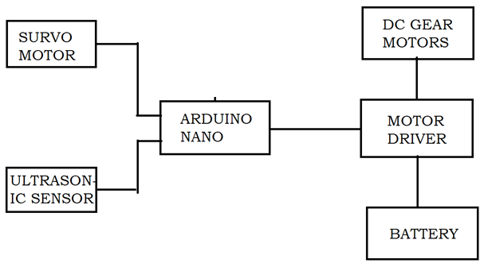
Fig.Block Diagram

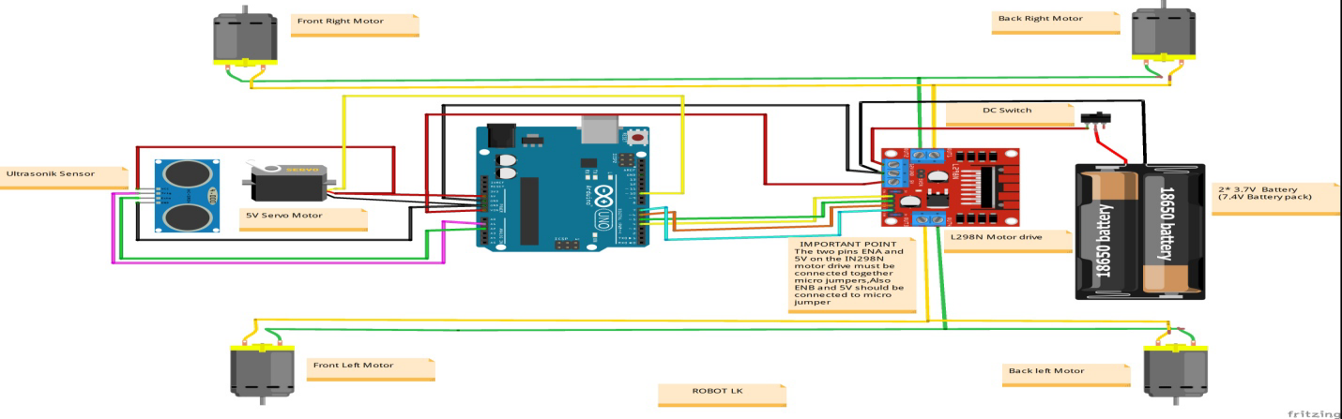

Fig. Circuit Diagram

5.CONCLUSION

In conclusion, the development and implementation of an automatic floor cleaning robot represent a significant advancement in the field of robotics and automation. Through this research, we have demonstrated the feasibility and effectiveness of utilizing robotic systems for floor cleaning tasks in various environments. The performance evaluation of our robot has shown promising results in terms of efficiency, accuracy, and adaptability to different floor surfaces.
The potential applications of automatic floor cleaning robots extend beyond residential settings to commercial spaces, industrial facilities, healthcare facilities, and beyond. By automating floor cleaning tasks, these robots can contribute to enhancing productivity, reducing labor costs, and maintaining cleanliness and hygiene standards in various environments.

Overall, the development of automatic floor cleaning robots holds great promise for revolutionizing the way floor cleaning tasks are performed. As technology continues to evolve, further research and innovation in this field will undoubtedly lead to even more sophisticated and efficient robotic systems capable of addressing the diverse needs of modern society.

- ACKNOWLEDGEMENT

It gives us great pleasure to remain deeply indebted to our esteemed guide Prof. S. G. Bavachkar under whom we had the privilege to work with the faith and confidence shown by her on us. She boosted our morel and motivated us to perform better in preparing the project.
We are also thankful to Prof. C. G. Kokane-Pawar (HOD CSE Dept.) and all staff members of our department for giving us guidance for making this project successfully.

REFERENCES

[1] Manreet Kaur and Preeti Abrol “Design and development of floor cleaner robot
(Automatic and manual)”, International Journal of Computer Application,
published in July 2014.

[2] J.Y. Sung, R. E. Grinter and H. I. Christensen in “Housewives domestic robot
technology international journal of social robotics” IEEE International Conference
on Human Robot Interaction, July 2012.

[3] Ajith Thomas, Rohith M.S, Febin Jolly, Jeeson Cheriyan, Ms.Renu Mary George, “
AnAdvanced Mobile Robot for Floor Cleaning” , International Journal of Advanced
Research in Electrical, Electronics and Instrumentation.

[4] Jens Steffen Gutmann, Kristen Culp, Mario E. Munich and Paolo Pirjanian “Social
impact of a systematic floor cleaner” IEEE International Workshop on Advanced
Robotics and Its Social Impact, published in May 2012.

[5] https://en.wikipedia.org/wiki/HC-05 Bluetooth Module Accessed 25 May 2018.

